**Developmental Robotics and Artificial Intelligence**

A Fascinating Description of Developmental Robotics and the role of Artificial Intelligence Presented as a Report in a Clear and Concise Way

**Submitted to:**

Dr. Usman Ghani

**Submitted by:**

Hamza Farooq (2016-CS-122)

Komal Shehzadi (2016-CS-178)



June, 2020

Contents

Table of Figures 3

Abstract 4

Introduction 4

Background 4

Types of Developmental Robots 5

1. Socially oriented interaction 5

Cozmo 5

2. Non-social interaction 6

Dobot M1 6

3. Agent-centered sensorimotor control 6

Scorpio Robot 7

4. Mechanisms and principles 7

BIM+ 8

Role of Artificial Intelligence in Developmental Robotics 8

Speech Recognition 9

Gesture Recognition 9

Text Recognition 10

Path Finding 10

Text to Speech 11

# Table of Figures

Figure 1 - Cozmo Robot 5

Figure 2 - DoBot M1 robotic arm 6

Figure 3 - Scorpio Robot 7

Figure 4 - BIM+ Construction Simulation Tool 8

Figure 5 - Flow diagram of Speech Recognition 9

Figure 6 - Flow diagram of Gesture Recognition 10

Figure 7 - An OCR 10

Figure 8 - A Path finding Algorithm 11

Figure 9 - Flow diagram of Text to Speech 11

# Abstract

In our everyday life, we often think of automation of our work. We pay for labor directly or indirectly. It is a need of personal as well as professional life to get the work done by some means. Because the human mind is superior in the animal kingdom, developers and scientists try to mimic the mind of human. It never has been an easy task to mimic the brain of a human. Scientists somehow have succeeded in developing the algorithms and techniques that can mimic the brain of human child or at least act as the child of human in things such as questioning like a child. Developmental Robotics is new and emerging category of research and development. These robots are also known as science-fiction or future robots because of their human-like learning nature.

Many kinds of AI algorithms are being used in Developmental Robots. These technologies are somewhat universal and can be implemented with a minor change. There techniques work interactively by establishing a weak or strong connection with another program. In this way, a program corridor is made in which a developer can analyze the combined learning process of the robot. This analysis may be useful in better understanding the learning process of actual human brain.

# Introduction

More than one branches and sub-branches of robotics and artificial intelligence make the field of developmental robotics (informally known as *DevRob*). In this field, scientists and engineers try to mimic the mind of real human child instead of an adult. This sort of development give rise to the open-ended learning. A child-like energy to query and question about the nature make the robot automatically grown to perceive better. The field is also known as ontogenetic robotics. Just like a child who have cumulative sense of perceiving the world. Learning is a progressive process that incrementally develops its roots in a human child with simple to more complex tasks of everyday routine.

Developmental Robotics differ from Evolutionary Robotics that use population of robotics. The robots interact with each other to evolve over the passage of time. In Developmental Robotics, the algorithms are implemented that yields to mimic the cognitive sense such as humans. As a consequence, the parent learning algorithm that is uploaded in the robot becomes more and more advanced. Developmental Robots give an opportunity to scientists and engineers to better understand that how human child learns and become mature over the passage of time.

# Background

What if robots could have a cognitive sense such as humans? What if robot brain become mature over the passage of time? These questions allow researchers to confront with the reality. It is never easy to implement the theory and bring it towards real world. The implementation of cognitive theories explicitly intersects at a point that these can only be implemented in non-human things that are robots. Scientific laws of experimentation also include not to use human as specimen for any scientific experiment in which any physical or psychological loss may come in occurrence. A powerful hardware with suitable architecture enough to mimic the human brain is required. Professional programmers, Data scientists and other contributing personnel with appropriate skills and experience are playing important in the evolving the generation of Developmental Robots.

# Types of Developmental Robots

The spectrum in which Developmental Robots fall is described with detail as below.

## Socially oriented interaction

This category encompasses robots that learn with human interaction, human negotiation and other social interactions. These robots are just like little friends of human. Examples of these robots are detailed below.

### Cozmo

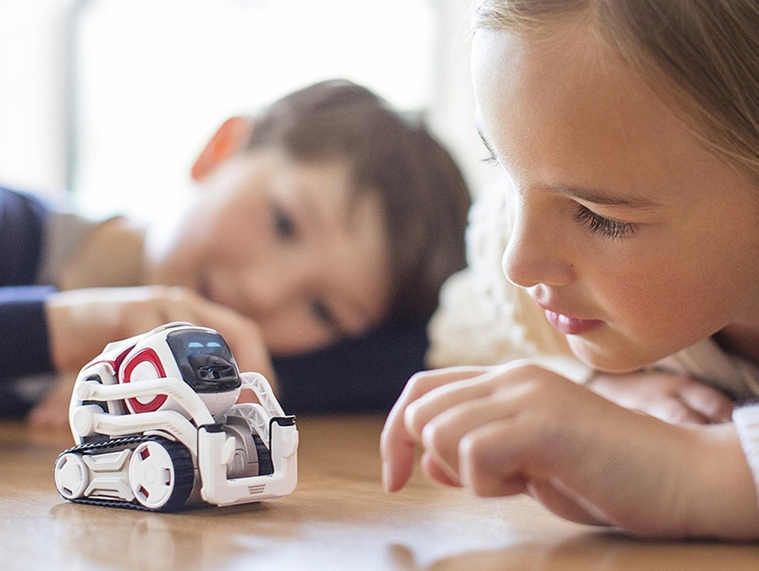

Figure 1 - Cozmo Robot

Cozmo is a socially active, machine learning based robot. It learns with human interaction. It can play games with humans. Provided with built-in integrated development environment, one can use code blocks to program the robot. Used in learning and exploring the programming skills. As an Education robot, it played its role very well. It is a little guy with his own mind.

## Non-social interaction

These types of robots perceive the environment on their own using sensors. There is a strong coupling and hardwired connection between motors and sensors. Theses sensors are used to observe the local environment to gather data that will be used to turn the learning algorithms on the fly such as visually guided grasping control such as in robot arms. Manipulation tool-use and navigation based on sensor data and local environment. Examples are detailed below.

### Dobot M1

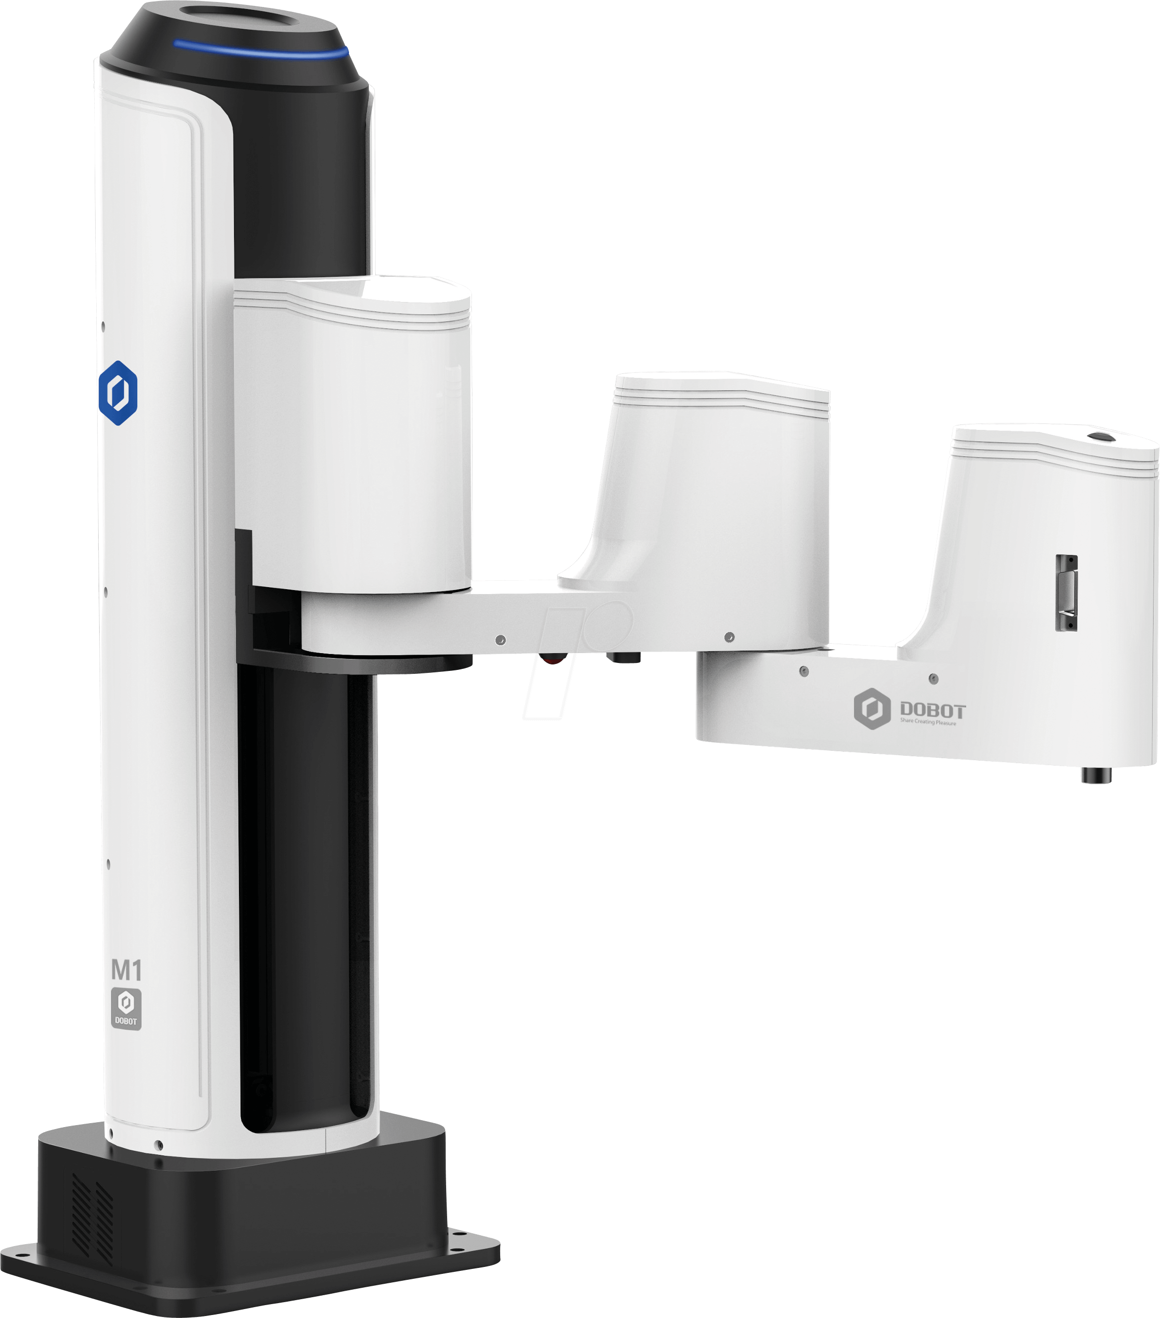

Figure 2 - DoBot M1 robotic arm

Dobot M1 is a professional robot arm loaded with sensors. It can be a 3d-printing machine, Laser engraver and hand tool. Multiple dobots can be connected to perform a single task. The arms interact with each other just like a group. It has precision and repeatability of 0.02mm. Repeatability means returning to the previous position with a significant precision.

## Agent-centered sensorimotor control

In these types of robots, the program investigates the change in environment or bodily capabilities over time. This investigation includes self-supervised learning such as perceptual acuity on the experience such as robots learning to crawl. The agent-centered robots differ from non-social interaction in the way that these robots cannot be trained other than the category of the environment or specimen awareness that has changed over time. Examples are explained below.

### Scorpio Robot

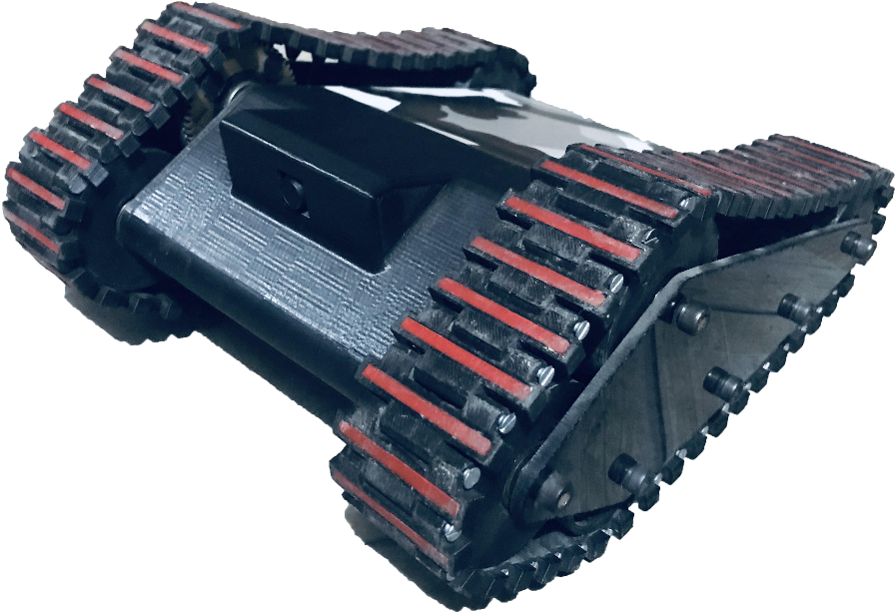

Figure 3 - Scorpio Robot

Scorpio is an agent-based robot. It supports livestream over Wi-Fi. Computer Vision algorithms are loaded on a PC-based IDE. Interaction commands are transcoded over the internet so that morphological learning against the environment perception can be easily automated. One popular application of the robot is detection of suspicious activity based on its environment learning. Scorpio is portable, 3d-printed and amazingly fast robot as compared to other locomotive bots.

## Mechanisms and principles

This category embraces to bring the theocratical mechanisms and motion principles to implementation. Usually this category does not include any motion robot or any physical movement mechanism such as motored robots. Most of the robots in this category are based on simulation. Simulation means to describe that how the models of real-world things interact each other and also in future with a change in their state. Prediction based bots and automated software that are used to anticipate the changings or warnings for threats. Many software applications are available to public. Solidworks is a mechanical design application that is used for computer aided designs and simulation of hardware mechanisms before they are actually made into physical structures. Proteus is another software application that support virtual system simulations to electric circuits and schematics. Sketches of electronic devices are made on it and simulated before the actual formation of printed circuit boards. Other than 3d model simulations and electronic circuits, many other software applications fall in this category such as manufacturing simulation in which a factory or an industrial placement of individual machines is simulated. One can observe the product formation from the raw materials provided, temperature control, humidity and air quality required for specific product manufacturing process. Examples include simulation programs such as described below.

### BIM+

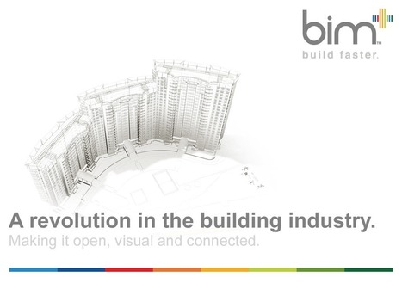

Figure 4 - BIM+ Construction Simulation Tool

BIM+ is abbreviation of Building Information Modelling. It is an artificial intelligence based, clash-free, predictive construction software used by millions of engineers and construction works worldwide. It supports team collaboration, involves change management and many other features. This software is a revolution in the world of construction engineering because it supports learning the pre-defined design and auto-completion that saves many of the designer’s time. Auto-suggest features make BIM+ distinctive in the world of computer aided design software.

# Role of Artificial Intelligence in Developmental Robotics

Typically, the Artificial Intelligence aided robots such as developmental robots have famed a lot of public attention. It is not an easy task to mimic the cognitive thoughts of human. A team of researchers and scientists is required to do so. The AI techniques and algorithms used to introduce cognition in a robot mind are discussed below. Robots implementing different AI techniques and algorithms are compared in the table below.

|  |  |  |  |  |
| --- | --- | --- | --- | --- |
|  | Ubtech’s Alpha 1s | Boston Dynamics’ Spot | Pepper | Softbank’s Nao |
| Speech Recognition | ✓ | ✕ | ✕ | ✓ |
| Gesture Recognition | ✓ | ✓ | ✓ | ✓ |
| Text Recognition | ✕ | ✕ | ✕ | ✓ |
| Path Finding | ✓ | ✓ | ✓ | ✓ |
| Text to Speech | ✕ | ✕ | ✕ | ✓ |

Significant AI algorithms that play central role in Developmental Robots are detailed below.

## Speech Recognition

Voice is taken as input to identify and categorize the patterns and repetition of pitch fluctuation in audio. Another field called natural language processing is correlated with speech recognition. Words and phrases of spoken language are often converted into text. Summary generation is also the part of this particular field.

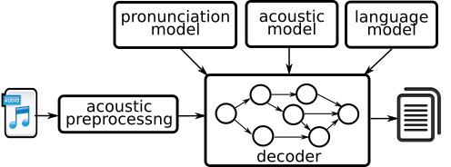

Figure 5 - Flow diagram of Speech Recognition

## Gesture Recognition

Gesture is the way of expression using body. Gestures make another language of its own. Identification and categorization of human gestures. A typical robot recognizes gestures and execute the corresponding command that may be a movement or another electrical signal.

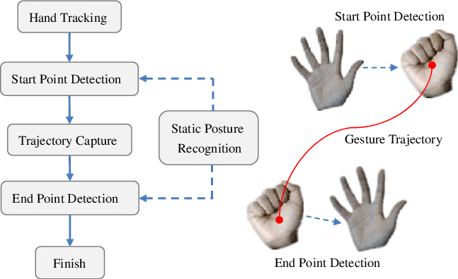

Figure 6 - Flow diagram of Gesture Recognition

## Text Recognition

This field is also known as Optical Character Recognition. Examples of OCR are number recognition on license plate, Handwriting recognition or signature recognition that is significant in fraud detection.

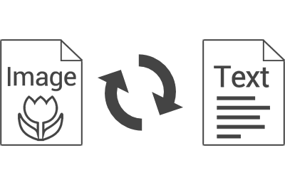

Figure 7 - An OCR

## Path Finding

This technique is significant in computer games and other tree-based decision-making algorithms. In this particular field of AI algorithms, typically a tree of decisions is explored through many ways in order to find the best possible solution to the problem given.

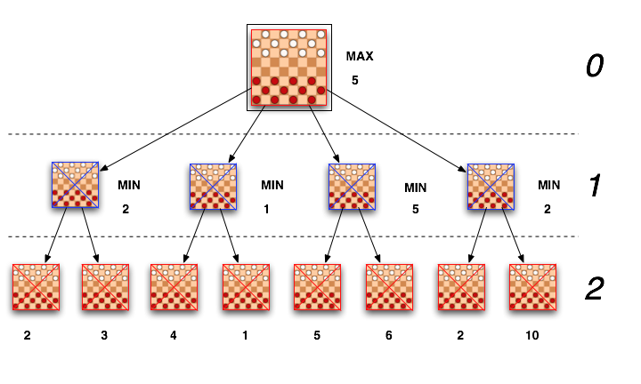

Figure 8 - A Path finding Algorithm

## Text to Speech

Text to speech is a sub-category of speech synthesis. In this technique, artificial speech-like sound is produced that is close to human voice. This particular use of AI is in the use of development of mostly portable products of everyday life such as smartphone.

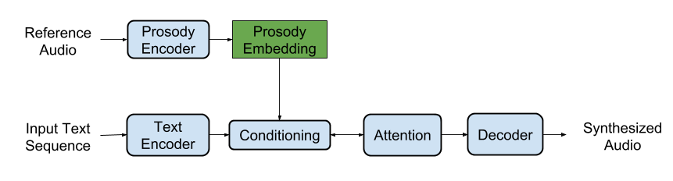

Figure 9 - Flow diagram of Text to Speech